I Made a Huge Mistake With This Website (and I’ve been paying for it ever since)

I bought this template. I can’t remember from where, but it was a trusted source. I think it’s lovely. It had all the features I wanted and more. In fact, it came with at least 100 coded pages and page fragments.

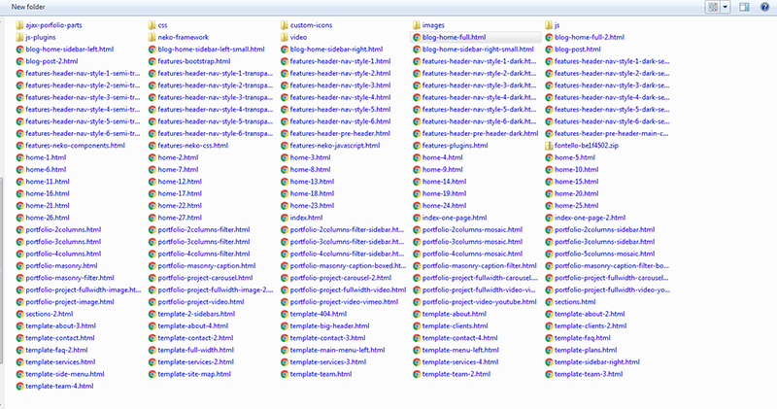

So—first problem—too much choice. It took me several weeks to look through all the files and combinations and decide to use a very small fraction of what was available. I wasted a lot of time, in my opinion, when I could’ve just gone to <a href=<https://html5boilerplate.com/>>HTML5 Boilerplate</a> and cranked out a one-pager in an hour, tops.

Problem two—Bootstrap. I was in a conversation with a developer who worked at Hired.com, and he said that Bootstrap is for people who don’t know how to code. I would say, you have to know how to code to use Bootstrap because everything but the kitchen sink is in there and in the templates I purchased. I can’t say how many times I’ve used the <strong>find</strong> feature on my Sublime Text 3 with Chrome Web Developer Inspector to try to figure out where in Hell’s Bells was a little tiny piece of CSS—styling code—amongst thousands and thousands of lines of code contained between four different style sheets.

I appreciate the amount of work that went into this template, I really do. I’ve never used Bootstrap before and I can see that it’s a reliable system to create consistent, responsive web pages, and that was certainly my plan. What I didn’t count on was the effort it was going to take to customize these template pages to my liking. And, I’m a perfectionist and a nit about design.

So I spent $11—a paltry sum, for a magnificent package of web page templates, CSS files, JavaScript files, animation, and more. I guess my greed got the better of my judgement. I got a really good deal. But these templates are not practical for me to customize. So I pay for my greed on a daily basis while I work on this website. Not being familiar with Bootstrap and especially their layout grid, I pour through line after line after line of Cascading Style Sheet code to find the one or two places that I need to make to footer simpler or to make sure my examples of work align in different browser sizes.

Why don’t I just start over, you might ask me? Well by this point I’ve invested way too much time, energy and curse words, in my judgement. I’ve got it mostly done. I’ve settled in places just to finish this because I feel it’s imperative to me being hired to do any sort of web work.

And the realization that I would be struggling to find individual code pieces didn’t really dawn on me until I was finished with my design and very happy with it. To recreate it from scratch just doesn’t make a lot of sense to me since I’m not really looking for a web design job; I’m more interested in writing, helping with accessibility, and user experience and interface design strategy. Not the actual coding part. Not since I gave up on learning JavaScript on my own.

I read some advice recently that I took to heart a while ago, and reading it just confirmed to me that I’d made the right decision. It said, “Give up on stuff you don’t like to do. Focus on stuff you like to do.” It was really, really hard for me to give up on JavaScript. I fought with it for a long time, on my own, to try to understand it and be a decent programmer. I could not do it. I believe I could learn JavaScript with help—pair programming or a mentor, or a live class. But I don’t like it. I don’t enjoy it one little bit. So after a lot of anguish I gave up on being a front-end developer.

So that’s why I am not being really picky about my code in this template. It is good enough for now, and I’m running out of time. I’ve been out of work for a long time due to various health problems and I’ve recovered to the point where I’m ready to go out again and try to find something with a remote option. I believe I could start full-time.

So I hope that if you’re a developer, you look past the imperfections in the code and grasp that I have the ability to code HTML and CSS properly should the need arise, and I certainly know enough about it to write about it. I won’t be writing about programming.

I’m going to stick with what I like for the remainder of my working career—helping people get better at what they do for their companies, or helping them use a product or service that I represent for an employer.

I think I made the right choice in the big scheme of things.